

NOVAC TECHNOLOGY SOLUTIONS

User Manual

Document Version No.: 1.00

Revision History
Version No | Reason For Changes | Author | Approver
0.01 | Draft | Anurag Kumar
1.00 | ENDORSEMENT WORDINGS (VAT EXEMPT) FOR MOTOR & FIRE PRODUCT | Anurag Kumar | NIJANTHAN PL

Table of Contents
1. Introduction 4

2. Exclusion of VAT 4

Introduction

- In the Financial endorsement, system should have the provision to excluded the VAT for full period.

Exclusion of VAT

- This is a financial endorsement type and it’s select to exclude the VAT amount for the respective policy. Once the endorsement request raised and the same needs to be approved. This endorsement is only applicable for full period.

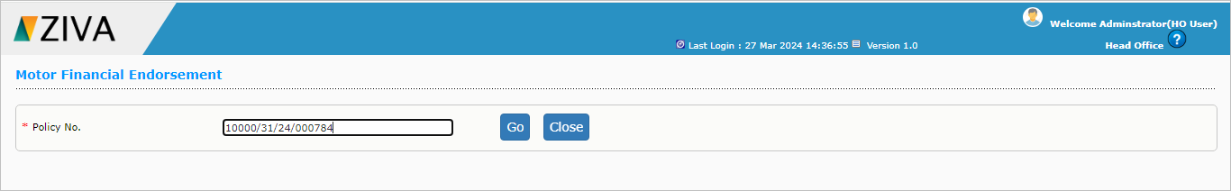

Click on Go button to go to Motor Financial Endorsement, enter the search value, and click on search button it will display the values.

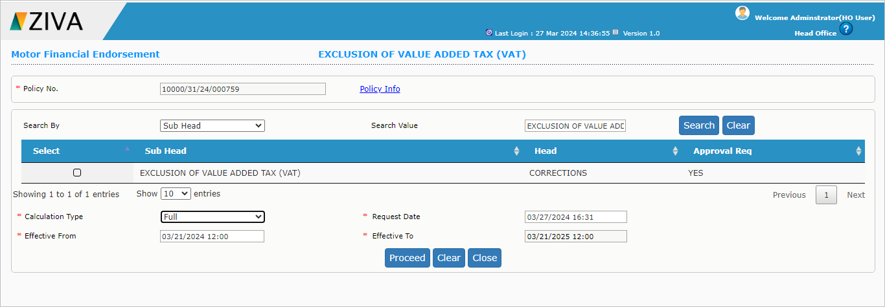

Now click on the checkbox and click on proceed button, system will redirect you to VAT Exempt tag.
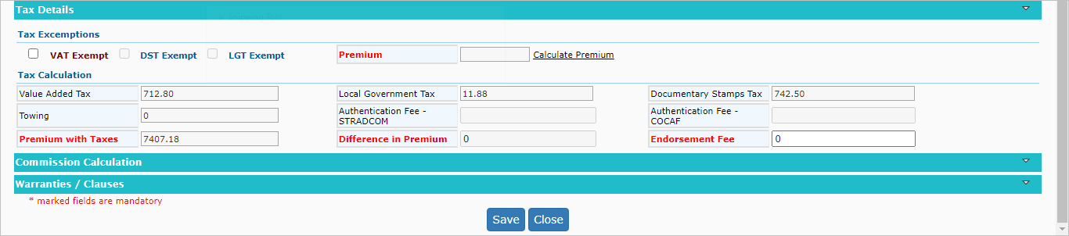

Click on VAT Exempt Checkbox and then click on calculate Premium and click on save button.
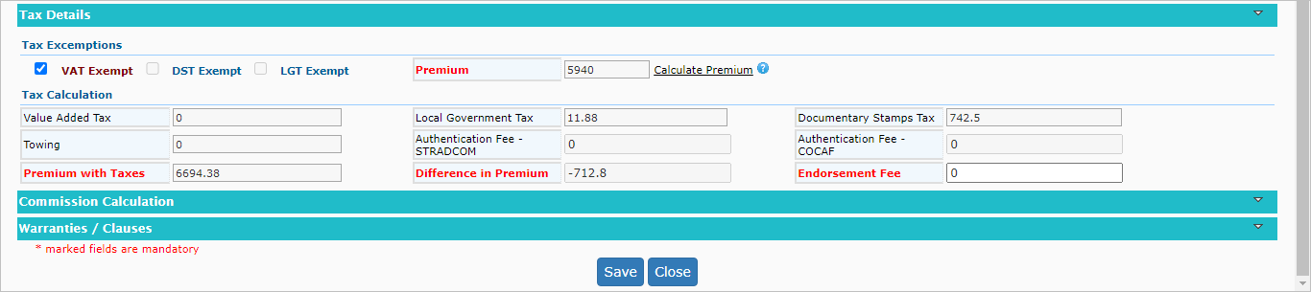
Now click on Submit button.
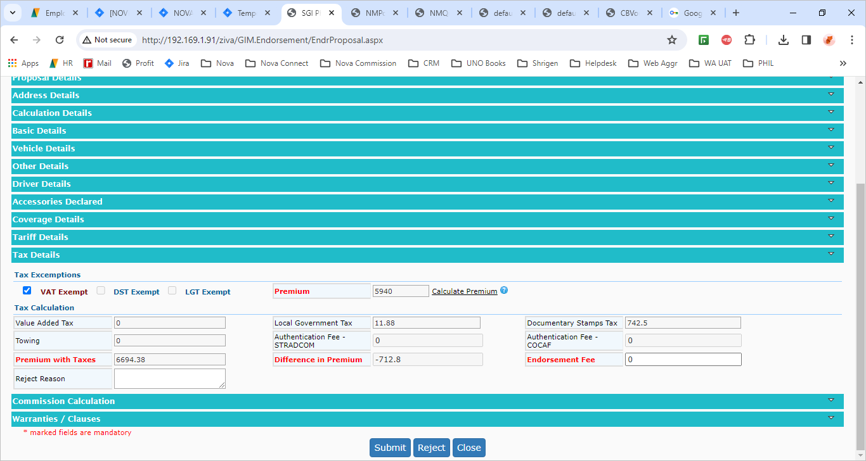
After Submit Endorsement will go to approval and once approval done. The Exclusion of VAT Endorsement will be completed.

